SCHOOLS BOOKING FORM – JOAN SUTHERLAND PERFORMING ARTS CENTRE 2019
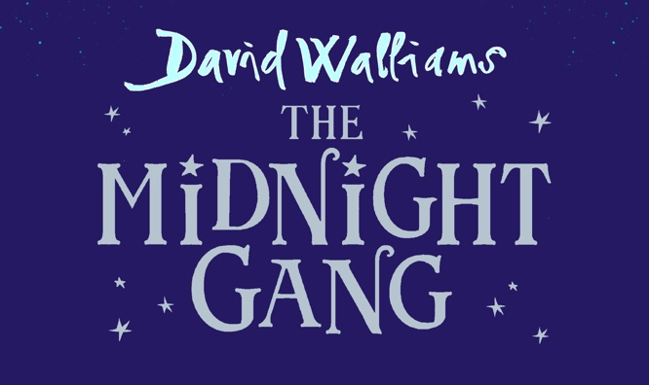

School Name____________________________________________________________________________________
Contact Name_____________________________________________Position_______________________________
Contact Person Email _____________________________________________________________________________
School Postal Address ____________________________________________________________________________
School Fax ____________________________________ Phone____________________________________________
School ABN _____________________________________________________________________________________

PERFORMANCE DATES/TIMES: Please select from the below performances.

Friday 6th December 10am Friday 6th December 12pm

TICKETS: Tickets are $22 each with one free adult ticket for every 20 paid tickets*

No. of children tickets: __________ @ $22.00* = total of $________
No. of free adult tickets (1 per 20 children) ______ @ $0.00 = total of $0.00
No. of adult tickets: _______ @ $22.00 = total of $________
Total no. Tickets __________ = Total ___________

RETURN FORMS: Email your completed form with the subject line:
“Joan Sutherland Performing Arts Centre Booking – The Midnight Gang”
To: boxoffice@penrith.city

*Once your form is received by Joan Sutherland Performing Arts Centre, you will be contacted to complete your reservation. If you would prefer to make your reservation by phone, please call the Box Office on (02) 4723 7600 (opening hours are 9am to 4:30pm Monday – Friday). Final numbers and payment will be required no later than 6 weeks prior to the performance date.

FOR A COPY OF THE TEACHERS RESOURCE KIT EMAIL education@cdp.com.au WITH YOUR BOOKING CONFIRMATION

